第一章 第三周

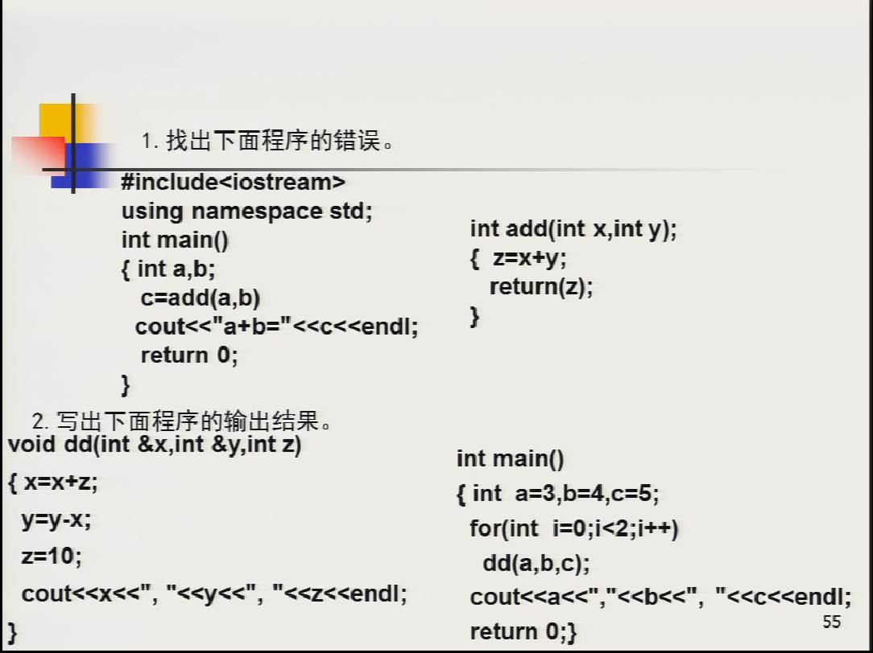

1.

#include <bits/stdc++.h>

using namespace std;

int add(int x, int y)

{

int z = x + y;

return (z);

}

int main(void)

{

int a = 1, b = 10;

int c = add(a, b);

cout << "a+b=" << c << endl;

return 0;

}

2.

#include <bits/stdc++.h>

using namespace std;

void dd(int &x, int &y, int z)

{

x = x + z; //1.8 2.13

y = y - x; //1.-4 2.-17

z = 10; //1.10 2.10

cout << x << "," << y << "," << z << endl;

}

int main()

{

int a = 3,b =4 ,c= 5;

for(int i=0; i<2;i++)

dd(a,b,c); //1.a=8 b=-4 c=5 2.13 -17 5

cout<<a<<","<<b<<","<<c<<endl;

return 0;

}

结果

8,-4,10

13,-17,10

13,-17,5

第二章

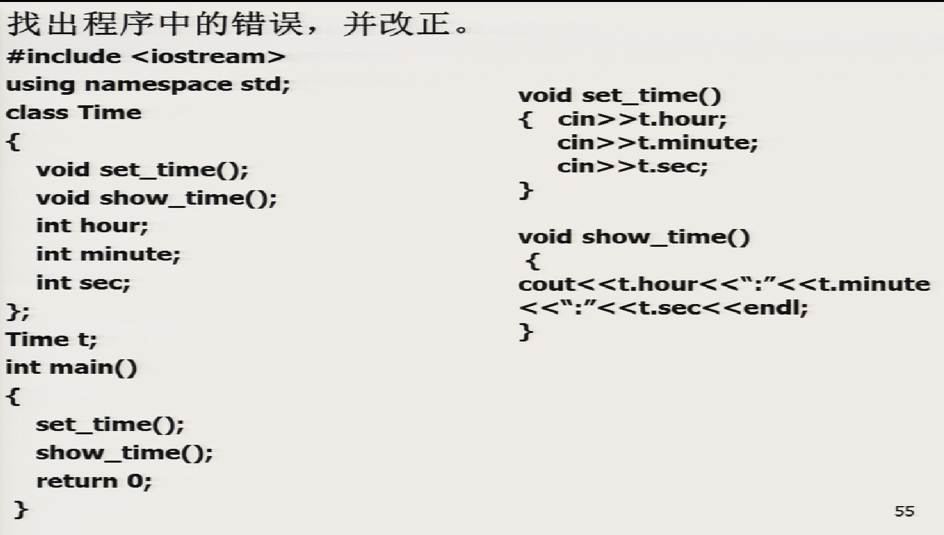

#include <bits/stdc++.h>

using namespace std;

class Time

{

public:

void set_time();

void show_time();

int hour;

int minute;

int sec;

};

void Time::set_time()

{

cin>>hour;

cin>>minute;

cin>>sec;

}

void Time::show_time()

{

cout<<hour<<":"<<minute<<":"<<sec;

}

Time t;

int main()

{

t.set_time();

t.show_time();

return 0;

}

第三章 第九周

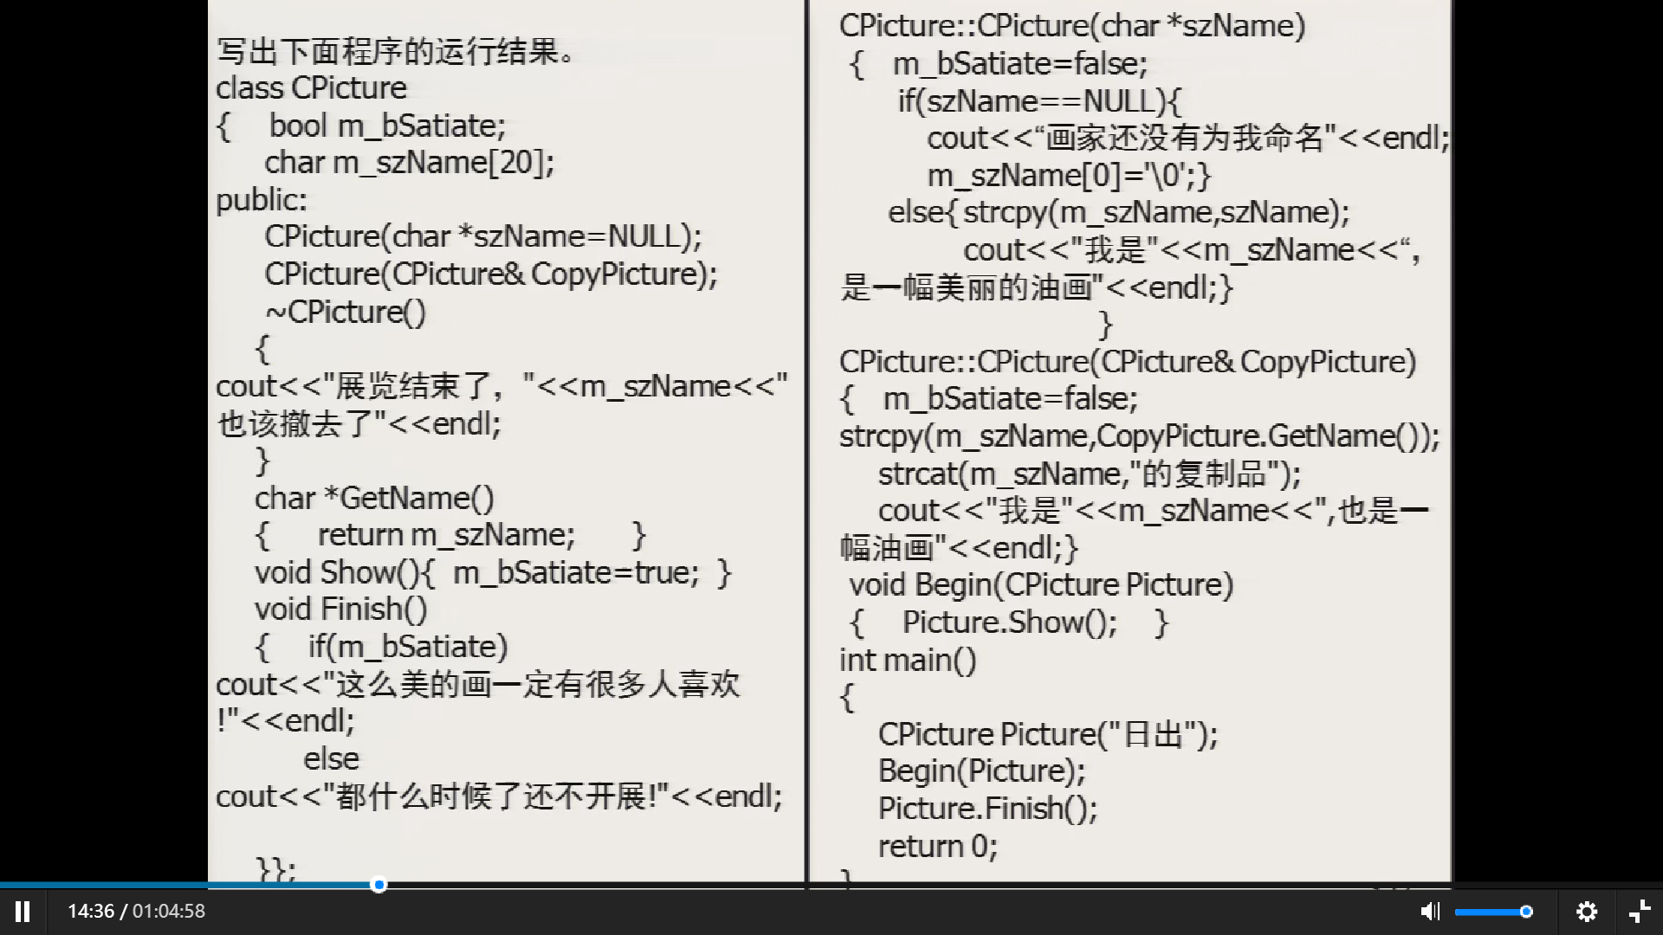

#include <bits/stdc++.h>

using namespace std;

class CPicture

{

bool m_bSatite;

char m_szName[20];

public:

CPicture(char *szName = NULL);

CPicture(CPicture &CopyPicture);

~CPicture()

{

// step 2

// step 4

cout << "展览结束了，" << m_szName << "也该撤去了" << endl;

}

char *GetName()

{

return m_szName;

}

void Show()

{

m_bSatite = true;

}

void Finish()

{

if (m_bSatite)

cout << "这么美的画一定有很多人喜欢！" << endl;

else

// step 3

cout << "都什么时候了还不开展！" << endl;

}

};

CPicture::CPicture(char *szName)

{

m_bSatite = false;

if (szName == NULL)

{

cout << "画家还没有为我命名" << endl;

m_szName[0] = '\0';

}

else

{

//step 1

strcpy(m_szName, szName);

cout << "我是" << m_szName << ","<< "是一幅美丽的油画" << endl;

}

}

CPicture::CPicture(CPicture &CopyPicture)

{

m_bSatite = false;

strcpy(m_szName, CopyPicture.GetName());

strcat(m_szName, "的复制品");

cout << "我是" << m_szName << ","<< "也是一幅美丽的油画" << endl;

}

void Begin(CPicture Picture)

{

//调用拷贝

Picture.Show();

//销魂 Picture

}

int main()

{

CPicture Picture("日出");

Begin(Picture);

Picture.Finish();

return 0;

}

结果

我是日出,是一幅美丽的油画

我是日出的复制品,也是一幅美丽的油画

展览结束了，日出的复制品也该撤去了

都什么时候了还不开展！

展览结束了，日出也该撤去了

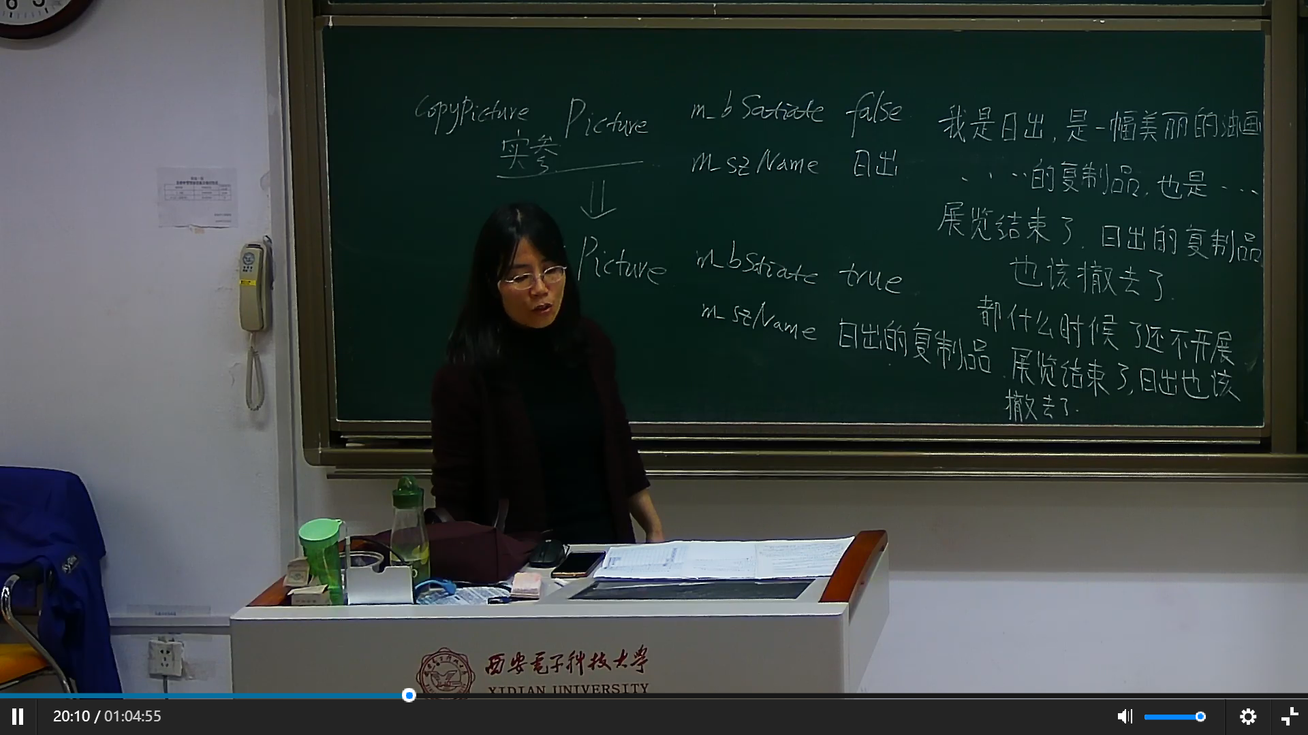

第四章 十二周

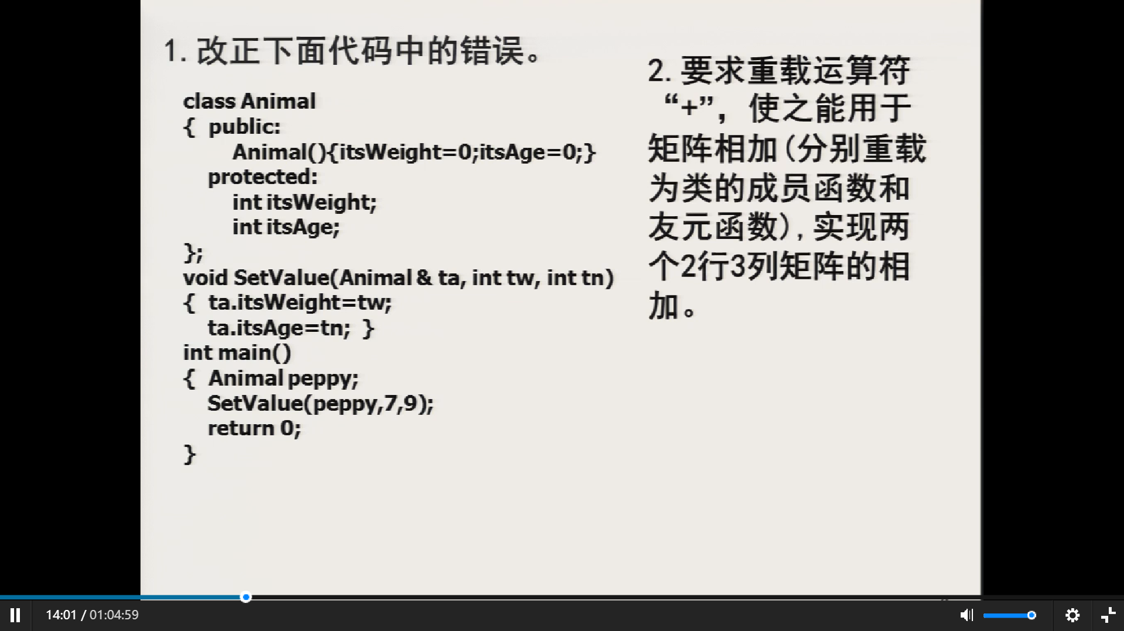#include <bits/stdc++.h>

using namespace std;

class Animal

{

public:

Animal(){

itsWeight = 0;

itsAge = 0;

}

friend void SetValue(Animal &ta,int tw,int tn);

protected:

int itsWeight;

int itsAge;

};

void SetValue(Animal &ta,int tw,int tn)

{

ta.itsWeight = tw;

ta.itsAge = tn;

}

int main()

{

Animal peppy;

SetValue(peppy,7,9);

return 0;

}

#include <bits/stdc++.h>

using namespace std;

class Matrix

{

private:

int mat[2][3];

public:

friend Matrix operator+(Matrix &a, Matrix &b);

};

Matrix operator+(Matrix &a, Matrix &b)

{

Matrix c;

for (int i = 0; i < 2; i++)

for (int j = 0; j < 3; j++)

c.mat[i][j] = a.mat[i][j] + b.mat[i][j];

return c;

}

#include <bits/stdc++.h>

using namespace std;

class Matrix

{

private:

int mat[2][3];

public:

Matrix operator+(Matrix &other)

{

Matrix c;

for (int i = 0; i < 2; i++)

for (int j = 0; j < 3; j++)

c.mat[i][j] = mat[i][j] + other.mat[i][j];

return c;

}

};

int main()

{

Matrix a, b;

Matrix c = a + b;

}

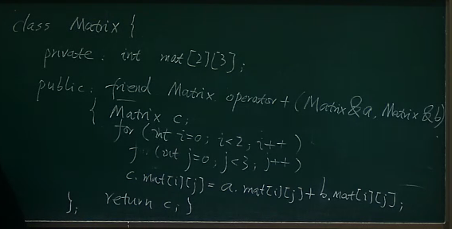

第五章 十三周

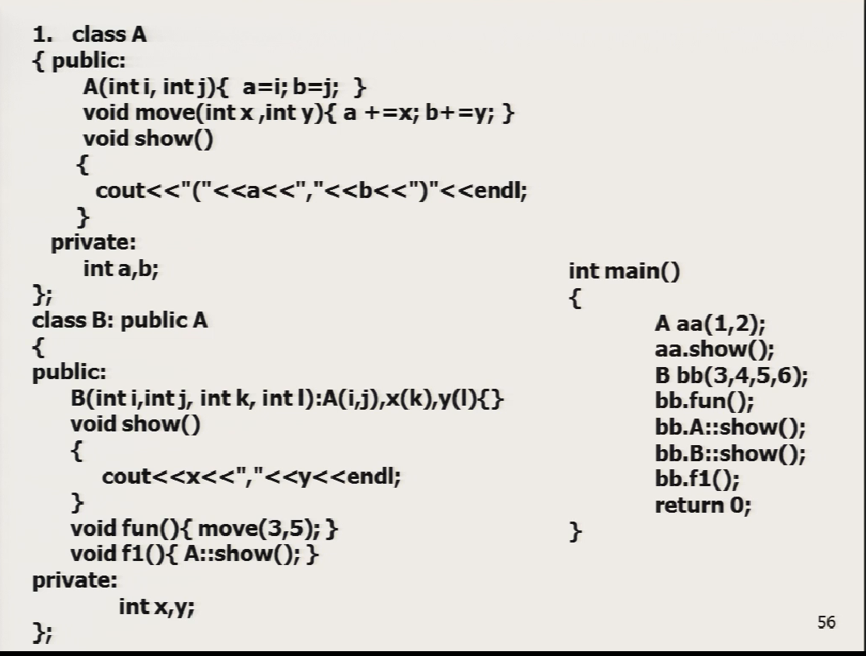

#include <bits/stdc++.h>

using namespace std;

class A

{

public:

A(int i,int j){a = i; b = j;}

void move(int x,int y){a+=x;b+=y;}

void show(){

cout<<"("<<a<<","<<b<<")"<<endl;

}

private:

int a,b;

};

class B: public A

{

public:

B(int i,int j,int k,int l):A(i,j),x(k),y(l){}

void show()

{

cout<<x<<","<<y<<endl;

}

void fun()

{

move(3,5);

}

void f1()

{

A::show();

}

private:

int x,y;

};

int main()

{

A aa(1,2);//i = 1,j = 2

aa.show();//(1,2)

B bb(3,4,5,6);//i = 3,j = 4,k = 5,l = 6

bb.fun();//i = 6,j = 9

bb.A::show();//(6,9)

bb.B::show();//5,6

bb.f1();//(6,9)

return 0;

}

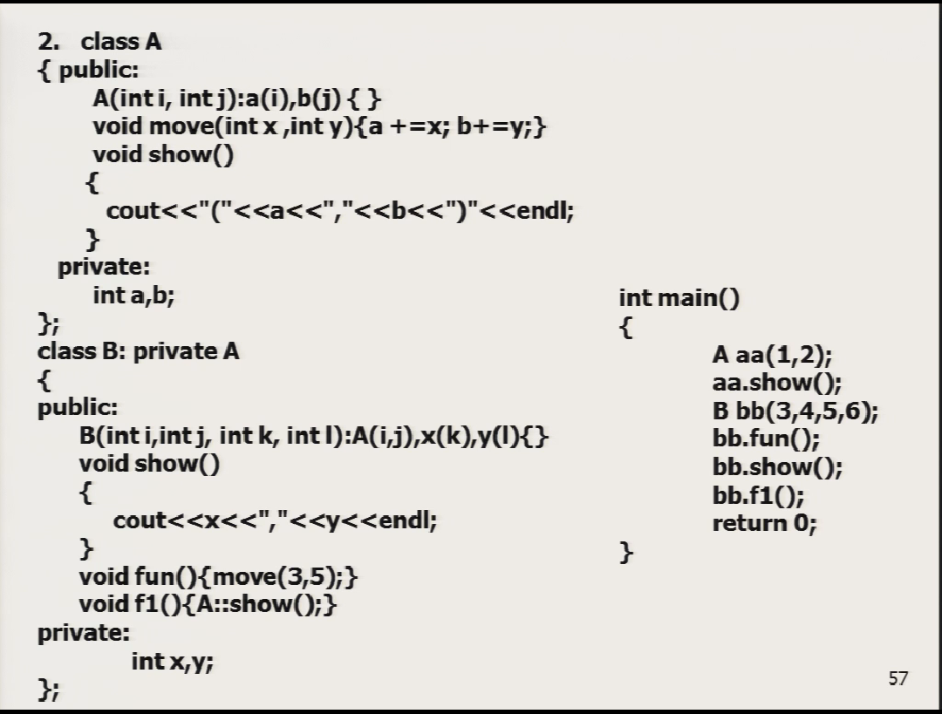

#include <bits/stdc++.h>

using namespace std;

class A

{

public:

A(int i,int j){a = i; b = j;}

void move(int x,int y){a+=x;b+=y;}

void show(){

cout<<"("<<a<<","<<b<<")"<<endl;

}

private:

int a,b;

};

class B: private A

{

public:

B(int i,int j,int k,int l):A(i,j),x(k),y(l){}

void show()

{

cout<<x<<","<<y<<endl;

}

void fun()

{

move(3,5);

}

void f1()

{

A::show();

}

private:

int x,y;

};

int main()

{

A aa(1,2);//i = 1,j = 2

aa.show();//(1,2)

B bb(3,4,5,6);//i = 3,j = 4,k = 5,l = 6

bb.fun();//i = 6,j = 9

bb.show();//5,6

bb.f1();//(6,9)

return 0;

}

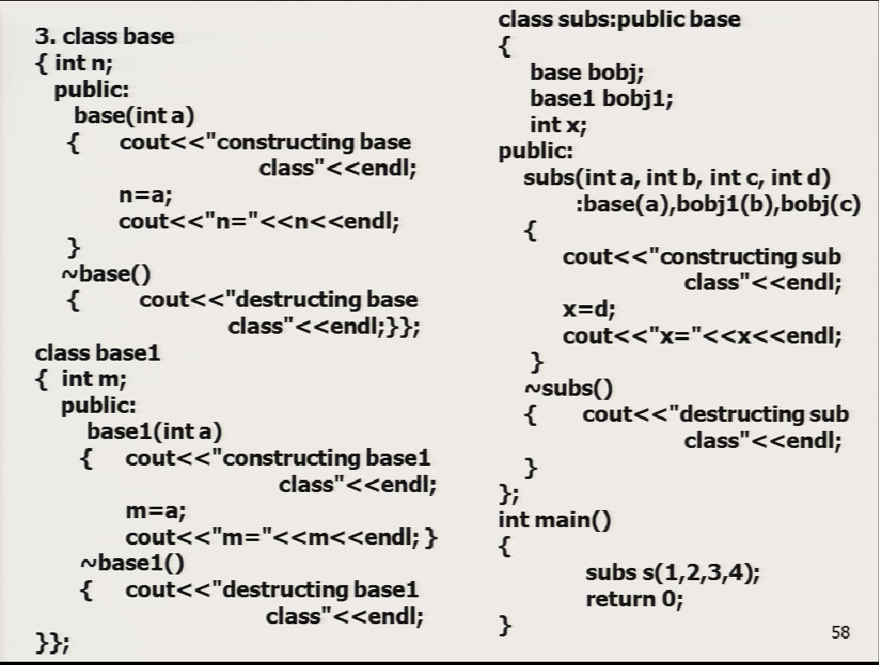

#include <bits/stdc++.h>

using namespace std;

class base {

int n;

public:

base(int a){

cout<<"constructing base class"<<endl;

n = a;

cout<<"n="<<n<<endl;

}

~base(){

cout<<"destructing base class"<<endl;

}

};

class base1

{

int m;

public:

base1(int a){

cout<<"constructing base1 class"<<endl;

m = a;

cout<<"m="<<m<<endl;

}

~base1(){

cout<<"destructing base1 class"<<endl;

}

};

class subs:public base

{

base bobj;

base1 bobj1;

int x;

public:

//step1 base(a) constructing base class n = 1

//step2 bobj(3) constructing base class n = 3

//step3 bobj1(2) constructing base1 class m = 2

//step4 subs(4) constructing sub class x = 4

//destructing sub class

//destructing base1 class

//destructing base class

//destructing base class

subs(int a,int b,int c,int d):base(a),bobj1(b),bobj(c)

{

cout<<"constructing sub class"<<endl;

x= d;

cout<<"x="<<x<<endl;

}

~subs()

{

cout<<"destructing sub class"<<endl;

}

};

int main()

{

subs s(1,2,3,4);

return 0;

}

第六章

**1.指出下面程序中的错误。**

**#include<iostream>**

**using namespace std;**

**class B**

**{**

**public:**

**void print()**

**{ cout<<"B class"<<endl; }**

**};**

**class D1:public B**

**{**

**public:**

**void print()**

**{ cout<<"D1 class"<<endl; }**

**};**

**class D2: B**

**{**

**public:**

**void print()**

**{ cout<<"D2 class"<<endl; }**

**};**

**int main()**

**{**

**B obj1,*p;**

**D1 obj2;**

**D2 obj3;**

**obj1=obj2; （A）**

**obj2.B::print(); （B）**

**p=&obj2; （C）**

**p->print();**

**p=&obj3; （D）**

**p->print();**

**return 0;**

**}**

**2.写出下面程序的运行结果。如果将Point类的area()函数定义为虚函数，其运行结果是什么？**

**#include<iostream>**

**using namespace std;**

**class Point**

**{ public:**

**Point(int x1,int y1)**

**{ x=x1; y=y1 ; }**

**int area() const {return 0;}**

**private:**

**float x,y;**

**};**

**class Rect: public Point**

**{**

**public:**

**Rect(int x1, int y1, int u1, int w1):Point(x1,y1)**

**{ u=u1; w=w1; }**

**int area() const {return u*w;}**

**private:**

**int u, w;**

**};**

**void fun(Point &p)**

**{**

**cout<<p.area()<<endl;**

**}**

**int main()**

**{**

**Rect rec(2,4,10,6);**

**fun(rec);**

**return 0;**

**}**

**0**

**60**

第七章

**int main()**

**{**

**int x=77;**

**cout<<"12345678901234567890\n";**

**cout.fill('#');**

**cout.width(10);**

**cout<<"x=";//默认右对齐**

**cout.width(10);**

**cout.setf(ios::left);//左对齐**

**cout.fill('$');**

**cout<<x<<"\n";**

**int y=0x2a;**

**cout<<"12345678901234567890\n";**

**cout.unsetf(ios::left);//右对齐**

**cout.fill('%');**

**cout.width(10);**

**cout<<"y=";**

**cout.unsetf(ios::right);//左对齐**

**cout.width(10);**

**cout.setf(ios::left);//左对齐**

**cout.fill('$');**

**cout<<y<<"\n";**

**return 0;**

**}**

**12345678901234567890**

**########x=77$$$$$$$$**

**12345678901234567890**

**%%%%%%%%y=42$$$$$$$$**

**int main()**

**{ int a=5,b=7,c=-1;**

**float x=67.8564,y=-789.124;**

**char ch='A';**

**long n=1234567;**

**unsigned u=65535;**

**cout<<a<<b<<endl;**

**cout<<setw(3)<<a<<setw(3)<<b<<"\n";**

**cout<<x<<","<<y<<endl;**

**cout<<setw(10)<<x<<","<<setw(10)<<y<<endl;//右对齐**

**cout<<setprecision(2);//有效为2位**

**cout<<setw(8)<<x<<","<<setw(8)<<y;**

**cout<<setprecision(4);//4位**

**cout<<x<<","<<y;**

**cout<<setprecision(1);//1位**

**cout<<setw(3)<<x<<","<<setw(3)<<y<<endl;//换行**

**cout<<"%%"<<x<<","<<setprecision(2);**

**cout<<setw(10)<<y<<endl;**

**cout<<ch<<dec<<","<<ch;//十进制**

**cout<<oct<<ch<<","<<hex<<ch<<dec<<endl;//八进制 十六进制**

**cout<<n<<oct<<","<<n<<hex<<","<<n<<endl;**

**cout<<dec<<u<<","<<oct<<u<<","<<hex;**

**cout<<u<<dec<<","<<u<<endl;**

**return 0;**

**}**

57

5 7

67.8564,-789.125

67.8564, -789.125

68,-7.9e+0267.86,-789.17e+01,-8e+02

%%7e+01, -7.9e+02

A,AA,A

1234567,4553207,12d687

65535,177777,ffff,65535